Session Goal
Students can complete courses in three areas- Michigan Transfer Agreement, Major-Specific Courses, and Electives to meet associate degree requirements. These courses should also meet bachelor’s degree requirements for students who enroll in the same program at the community college and university. The goal of this session is to provide a structure for faculty to identify required, recommended, optional and appropriate courses that meet associate and bachelor’s degree program requirements, especially in major-specific courses and program electives.

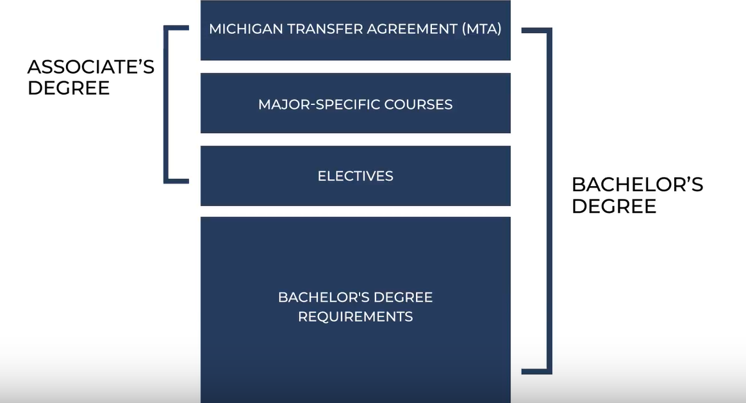

Assumptions
- Required, recommended, optional, and appropriate courses are those courses that students should complete early in the program, assuming that the student has selected a major.
- Courses in the first- and second- year or courses that meet associate degree requirements intends are terms we use interchangeably to refer to courses students complete in the first 60 hours. Some students will enroll part-time and enroll for longer to complete the associate degree and the courses.
- This activity focuses on students who intend to earn a bachelor’s degree. There are occupational programs at the associate degree level in some disciplines (i.e. business or police academy), but we are focused on the transfer associate degree and bachelor’s degree requirements.
- 90 minutes may not be an adequate amount of time to complete this task. We will schedule a second meeting to discuss lingering issues that require additional information and discussion.

Process Overview
There are five steps in the process outlined below. Faculty will review required, recommended, optional and appropriate in the first and second year; report these courses; refine the list of courses; discuss how these courses meet associate and bachelor’s degree requirements; and document the list of courses in preparation for the next steps of the process. This process is led by faculty, but session facilitators will indicate when it is time to move to the next step.

Process Instructions

Step 1: Review (15 minutes)
Review required, recommended, optional, or appropriate courses in the first- and second- year.
Using the catalog and program guides from your institution, review the program requirements of the associate or bachelor’s degree and identify required, recommended, optional and appropriate courses in the first- and second- year. Focus on program-specific courses and electives or other requirements that are necessary for students to be ready to take upper-division courses in the third and fourth years. At your tables, note these courses in preparation for step 2.

Step 2: Report (15 minutes)
Report required, recommended, optional or appropriate courses in the first- and second- year.
For university faculty, use the posters and institutional cards provided to indicate the required, recommended, optional, or appropriate courses in the first- and second- year at your institution. For each course, place your institutional card in the “Required/ Recommended/ Optional” box or the “Not Recommended” box. For community college faculty, use the card to indicate if you teach the course at your institution. This step oversamples courses that may be completed in the first- and second- year. The next step will refine this list of courses.

Step 3: Refine (15 minutes)
Refine required, recommended, optional or appropriate courses in the first- and second- year.
Step 2 oversampled the required, recommended, or optional courses in the first and second year. This step is designed to refine that list of courses. As a group, cluster the courses into three groups:
- Courses that are most commonly required, recommended or optional.
- Courses that are not commonly required, recommended or optional.
- Courses that are potentially offered, but institutions are mixed.

Step 4: Discuss (30 minutes)
Discuss the most common required, recommended, optional, or appropriate in the first and second year.
As a group, review the most commonly required, recommended or optional courses. Using the Community College Program Worksheet and the University Worksheet, consider how these courses fit in the associate and bachelor’s degree program requirements at your institution. During this step, you should be developing a list of program-specific and elective courses that students can complete in the first and second year.

Step 5: Document (15 minutes)
Document the required, recommended, optional or appropriate courses in the first and second year.
As a group, document the courses that are most commonly required, recommended or are optional in the first and second year. This list of courses will be used for three activities between this meeting and the next faculty convening.
- Community college faculty will use the list of common courses to document the associate degree requirements on the Community College Program Worksheet.
- University faculty will use the list of common courses to document how the courses fit in the bachelor’s degree requirements.
- Community colleges and universities will work together to confirm, revise or create direct equivalencies for the common courses identified in the program (see course equivalency matrices).

Document Recommended Courses
Use this table to document the courses that faculty recommended during the convening.

BIOLOGY  Recommended Course (per faculty convening) | Course Subject/Number (at your institution)
General Biology – Cell/Molecular
General Biology – Organismal
General Chemistry I
General Chemistry II
Organic Chemistry I
Organic Chemistry II
Physics I
Physics II

BUSINESS ADMINISTRATION  Recommended Course (per faculty convening) | Course Subject/Number (at your institution)
Microeconomics
Macroeconomics
Financial Accounting
Managerial Accounting
Business Law
Computer Information Systems

CRIMINAL JUSTICE  Recommended Course (per faculty convening) | Course Subject/Number (at your institution)
Introduction to Psychology
Introduction to Sociology
Introduction to Criminal Justice
Criminology
Introduction to Corrections

PSYCHOLOGY  Recommended Course (per faculty convening) | Course Subject/Number (at your institution)
Introduction to Psychology
Abnormal Psychology
Developmental Psychology -OR-
Child Psychology
Social Psychology
Personality -OR-
Human Sexuality

Next Steps

We will reconvene faculty groups in Fall 2018 with the goals of 1) addressing any issues identified in this convening, 2) reviewing the program worksheets and course equivalencies matrices and 3) recommend to college and university administrative leadership the courses that should be included in the associate to bachelor’s degree transfer pathways agreement. Faculty are asked to complete the following tasks before the Fall 2018 meeting. In addition to the worksheets, we will share more detailed instructions about this work after today’s convening.
PARKING LOT
tHERE WILL BE ISSUES AND CONCERNS THAT WE WILL NOT ADDRESS IN THIS SESSION. IDENTIFY THESE ISSUES IN THE “PARKING LOT”. THESE ISSUES WILL BE DISCUSSED ELECTRONICALLY OR AT THE NEXT meetING.

Community College Program Worksheet
Community college faculty will use the list of common courses to document the associate degree requirements on the Community College Program Worksheet.

University Program Worksheet
University faculty will use the list of common courses to document how the courses fit in the bachelor’s degree requirements on the University Program Worksheet.

Course Equivalency Matrices
Community colleges and universities will work together to confirm, revise or create direct equivalencies for the common courses identified in the program (see course equivalency matrices).

