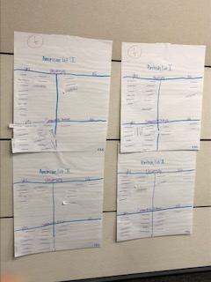

Left Column: American Lit I, II

Right Column: British Lit I, II

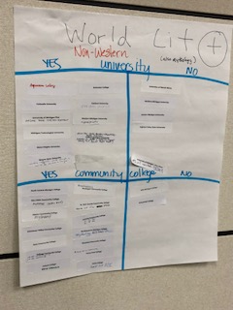

World Literature

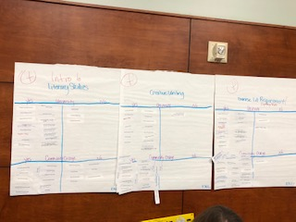

(L-R) Literary Studies, Creative Writing, Diverse Lit Requirement

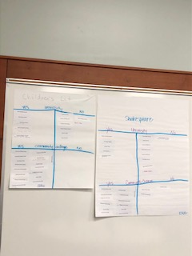

(L-R) Children’s Literature, Shakespeare

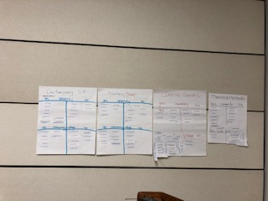

(L-R) Contemporary Literature, Rhetoric/Comp, Genre Courses, Theories and Methods

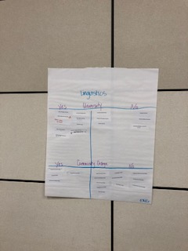

Linguistics

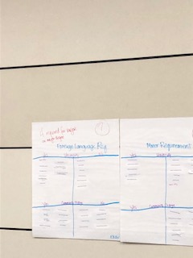

(L-R) Foreign Language Requirement, Minor Requirement

